

**A PROJECT REPORT**

**on**

**“RESTAURANT BILLING SYSTEM”**

**Submitted to**

**KIIT Deemed to be University**

**In Partial Fulfillment of the Requirement for the Award of BACHELOR’S DEGREE IN**

**INFORMATION TECHNOLOGY**

**BY**

| **MD.ALTAMASH DANYAL** | **2106036** |
| --- | --- |
| **MD.DILSHAD ALAM** | **2106037** |
| **SHUBHAM KUMAR** | **2106070** |
| **MD. JUNED EQBAL** | **2106124** |
| **PRAKASH KUMAR** | **2106132** |

**UNDER THE GUIDANCE OF**

**Dr. Arup Abhinna Acharya**



**SCHOOL OF COMPUTER ENGINEERING**

**KALINGA INSTITUTE OF INDUSTRIAL TECHNOLOGY**

**BHUBANESWAR, ODISHA - 751024**

**April 2024**



**KIIT Deemed to be University**

**School of Computer Engineering Bhubaneswar, ODISHA 751024**



**CERTIFICATE**

**This is certify that the project entitled restaurant BILLING SYSTEM**

| **submitted by** |  |
| --- | --- |
| **MD.ALTAMASH DANYAL** | **2106036** |
| **MD. DILSHAD ALAM** | **2106037** |
| **SHUBHAM KUMAR** | **2106070** |
| **MD. JUNED EQBAL** | **2106124** |
| **PRAKASH KUMAR** | **2106132** |

**is a record of bonafide work carried out by them, in the partial fulfillment of the requirement for the award of Degree of Bachelor of Engineering (Computer Science &amp; Engineering OR Information Technology) at KIIT Deemed to be university, Bhubaneswar. This work is done during year 2023-2024, under our guidance.**

**DATE: 04/05/2023**

**Dr. Arup Abhinna Acharya PROJECT GUIDE**



**Acknowledgement**

**We are profoundly grateful to Dr. Arup Abhinna Acharya of Affiliation for his expert guidance and continuous encouragement throughout to see that this project rights its target since its commencement to its completion. .....................**

| **submitted by** |  |
| --- | --- |
| **MD.ALTAMASH DANYAL** | **2106036** |
| **MD. DILSHAD ALAM** | **2106037** |
| **SHUBHAM KUMAR** | **2106070** |
| **MD. JUNED EQBAL** | **2106124** |
| **PRAKASH KUMAR** | **2106132** |

## TABLE OF CONTENTS:

1. **INTRODUCTION**
   1. PROJECT AIMS AND OBJECTIVES
   2. BACKGROUND OF PROJECT
   3. OPERATION ENVIRONMENT

## SYSTEM ANALYSIS

* 1. SOFTWARE REQUIREMENT SPECIFICATION
     1. GENERAL DESCRIPTION
     2. PROBLEM STATEMENT
     3. SYSTEM OBJECTIVE
  2. SOFTWARE AND HARDWARE REQUIREMENT
     1. SOFTWARE REQUIREMENT
     2. HARDWARE REQUIREMENT
  3. EXISTING VS PROPOSED
  4. SOFTWARE TOOL USED

## SYSTEM DESIGN

* 1. DATA FLOW DIAGRAM’S

## SYSTEM IMPLEMENTATION

* 1. MODULE DESCRIPTION
  2. SCREEN SHOTS

## SYSTEM TESTING

* 1. UNIT TESTING
  2. INTEGRATION TESTING

## CONCLUSION & FUTURE SCOPE

1. **REFERENCES**



**ABSTRACT:**

The project titled “RESTAURANT BILLING SYSTEM” is design with Visual Studio. restaurant owner has to maintain records of daily billing, which will be used to manage sale report. There will be many items available in the restaurant, many customers will be coming at different time for having food, they will be selecting items from the displayed menu and their bills will be generated. This system will save time and will be easy to use when compared to manual work that was done in paper.

**CHAPTER 1:**

**INTRODUCTION:**

Restaurant Billing System is an application, which will help restaurants /restaurants to optimize and control over their restaurants and restaurants menu. This application helps the restaurants to do all functionalities more accurately and efficiently. Restaurant Management system reduces manual work and improves efficiency and rate of work. It is specifically designed for restaurant billing management and order taking management system. This software helps to take food orders and display them. Also, help to maintain records in system and display total sale report. It is keeping a proper record of the bills.

* 1. **AIMS AND OBJECTIVES:**

The project aim and objectives that we will achieve after the completion of this project are;

* + 1. To take orders
    2. To add item
    3. To remove item
    4. To edit item
    5. To display menu
    6. To show bill
    7. To display total sale reports

**Take Orders:**

User will take orders from the customer, and only order will be taken at a time. After taking the order system will ask the customer whether to add more item in the order if yes, items will be added and bill will be displayed.

#### Add Item:

If restaurant staff wants to the add any item in the menu list, they can add through this function. It’ll first ask to enter item code and then to enter the price of the item. Then the new item wil be added to the menu.

#### Edit Items:

If the management of the restaurant wishes to edit the already added items in the menu, they can edit it through this function. It could be the code of the item or the price.

#### Delete Items:

If the restaurant has to remove some of it items from the menu list that they are no longer offering they can delete that item from this menu by entering the item code.

#### Display Menu:

When the customers come to give the order, menu will be displayed to them with their prices.

#### Show Bill:

If the management of the restaurant wants to search a specific bill, they can search that bill by entering the bill number.

#### Total Sale Report:

If the owner of the restaurant wishes to see his total sale report he can check the report through this function, which will display all the bills with their numbers.

# BACKGROUND OF PROJECT:

restaurant Management System is based on a concept of ordering food items and generating total food cost. The user can make an order by selecting from the main menu. This mini project contains limited features, but the essential one. Talking about the features of the food ordering system, the system displays a menu of all food items with their prices and the user has to select any of them to order. There should be one order at a time. After selecting, an order the system asks whether to add more items, and then proceeds to the quantity of that item. After all these, the system saves the order and asks whether to add another order or not. Then the system generates the bill for the customer. At last, a bill receipt is displayed with the bill number, and the total bill amount in rupees.

* 1. **OPERATION ENVIRONMENT:**

| PROCESSOR | AMD Ryzen 7 5700U |
| --- | --- |
| OPERATING SYSTEM | WINDOWS 7/8/10/11 |
| MEMORY | 500MB-1GB RAM |
| HARD DISK SPACE | AN HDD FOR PERMANENT STORAGE |

**CHAPTER 2:**

**SYSTEM ANALYSIS:**

In this chapter, we will discuss and analyze about the developing process of restaurant Management System including software requirement specification (SRS) and comparison between existing and proposed system. The functional and non-functional requirements are included in SRS part to provide complete description and overview of system requirement before the developing process is carried out. Besides that, existing vs proposed provides a view of how the proposed system will be more efficient than the existing one.

* 1. **SOFTWARE REQUIREMENT SPECIFICATION**

## GENERAL DESCRIPTION

restaurant Management System is a computerized system, which helps user (restaurant) to manage the customer bill records in electronic format. It reduces the risk of losing records, and reduces time consumption. It can help user to manage the orders and bills of customers efficiently.

## PROBLEM STATEMENT:

The problem occurred before having computerized system includes:

* + - * Manual ordering was time consuming.
      * Bills were less accurate.
      * Ordering food was complicated for customers.
      * Managing records in the form of papers was a difficult and risky task.

## SYSTEM OBJECTIVE:

* + - * Improvement in control and performance.
      * The system is develop to cope up with the current issues and problems of taking food orders & billing.
      * It has reduced time consumption.
      * Bills are more accurate.
      * Bill generation is easier than before.
      * It is easier to order food for a customer.
      * Records are more secure in computerized form rather than paperwork.

## SOFTWARE REQUIREMENTS

This section describes the software and hardware requirements of the system

* + - * Operating system Windows 7, 10 is used as the operating system as it is stable, supports more features, and is more user friendly.
      * .Development tools and Programming language- PYTHON

## HARDWARE REQUIREMENTS

* + - * AMD Ryzen 7 5700U 10th generation is used as a processor because it is faster than other processors and provides reliable and stable working and we can run our pc for longtime.
      * By using this processor, we can keep on developing our project without any worries.
      * Ram 16 GB is used, as it will provide fast calculations and performance.

# EXISTING VS PROPOSED SYSTEM:

### Existing system does not have option for displaying total sale report whereas proposed system will have it.

* Existing system does not have option for searching a specific bill however; proposed system will be having this option.
* Existing system is not yet user attractive, while in proposed system it was so.

# SOFTWARE TOOL USED:

The software used in this project is Visual Studio

**CHAPTER 3 SYSTEM DESIGN**

# 3.1 FLOWCHART OF SYSTEM

### START

READ INPUT

Generate & Display Bill

Quantity

Select Item

If input==1?

Take Order

If input ==2?

Add

Item

Add Item & Details

If input == 3?

Remove

Item

Remove Item & Details

If input == 4?

Edit Item

Edit Item & Details

### EXIT

If input ==5?

Display

Menu

Display the menu food list

If input == 6?

Preview Bill

Search Specific Bill Record

Display Of Bill Record

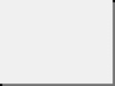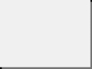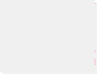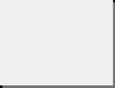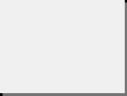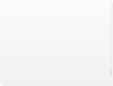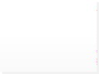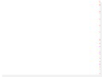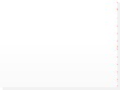

If input == 7?

Total Sale Report

Display All Bills Records

**CHAPTER 4**

**SYSTEM IMPLEMENTATION:**

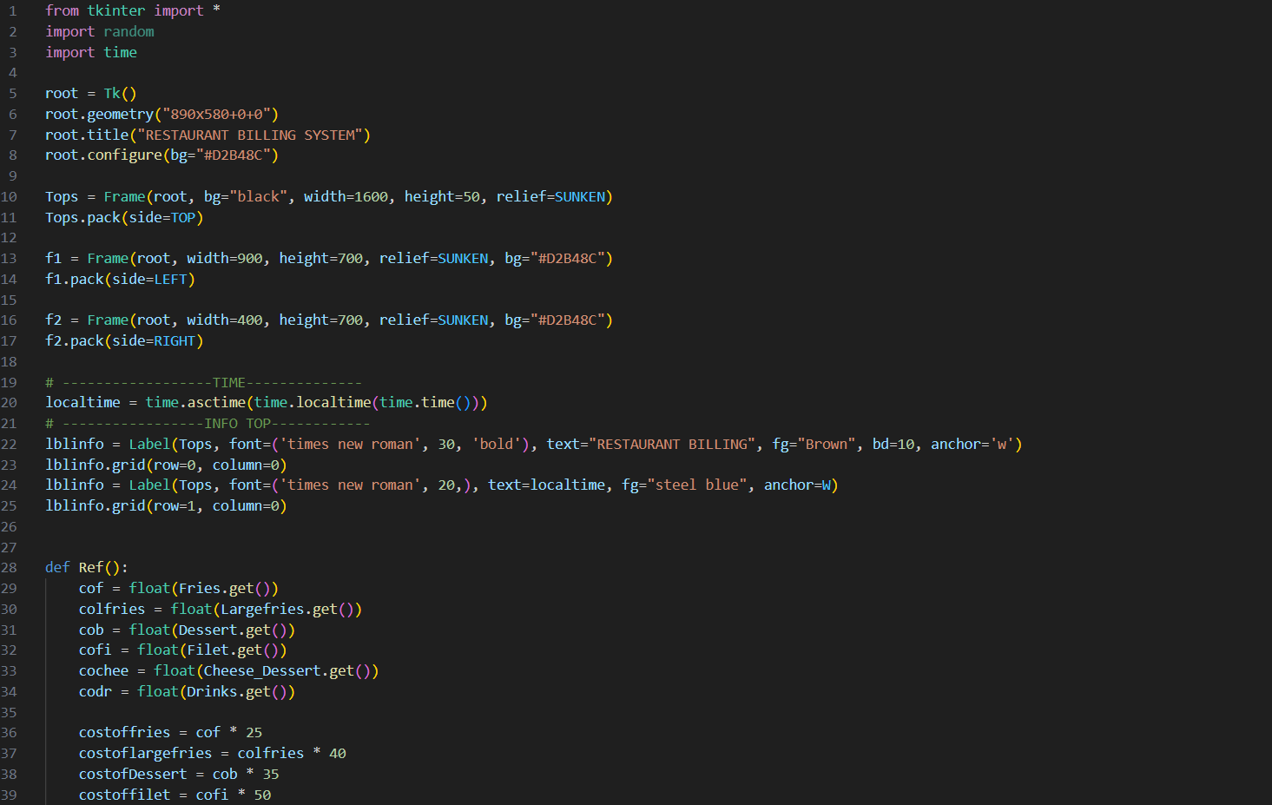

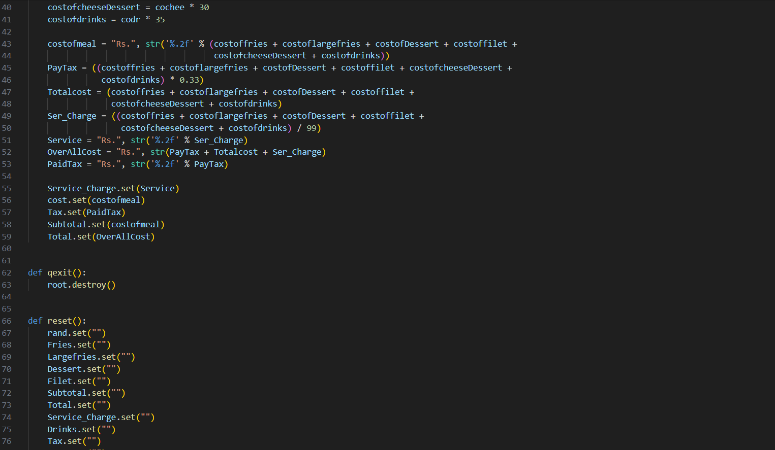

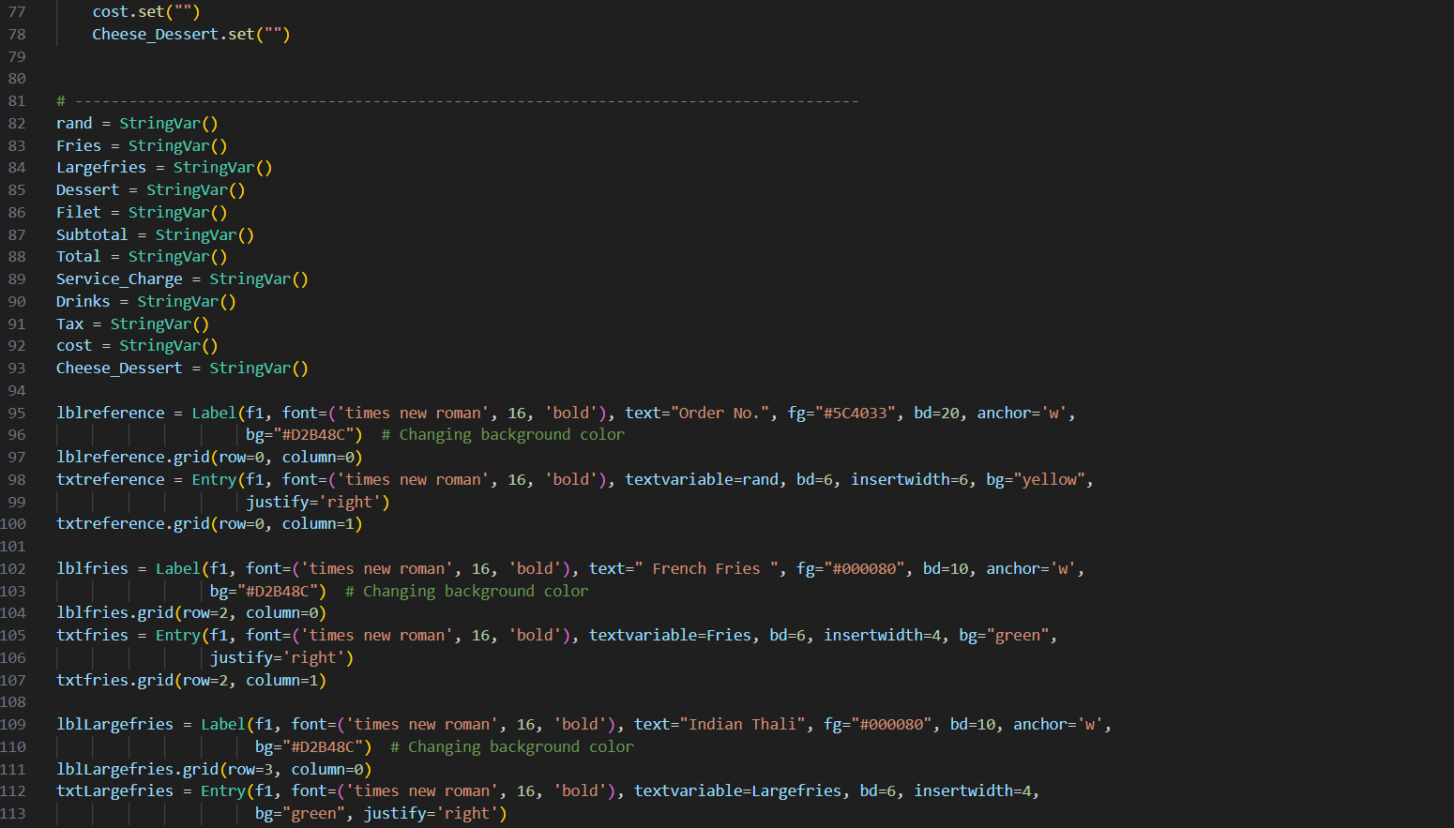

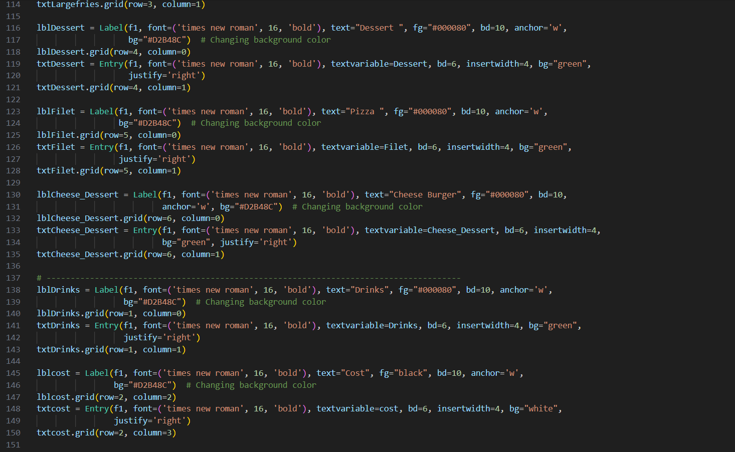

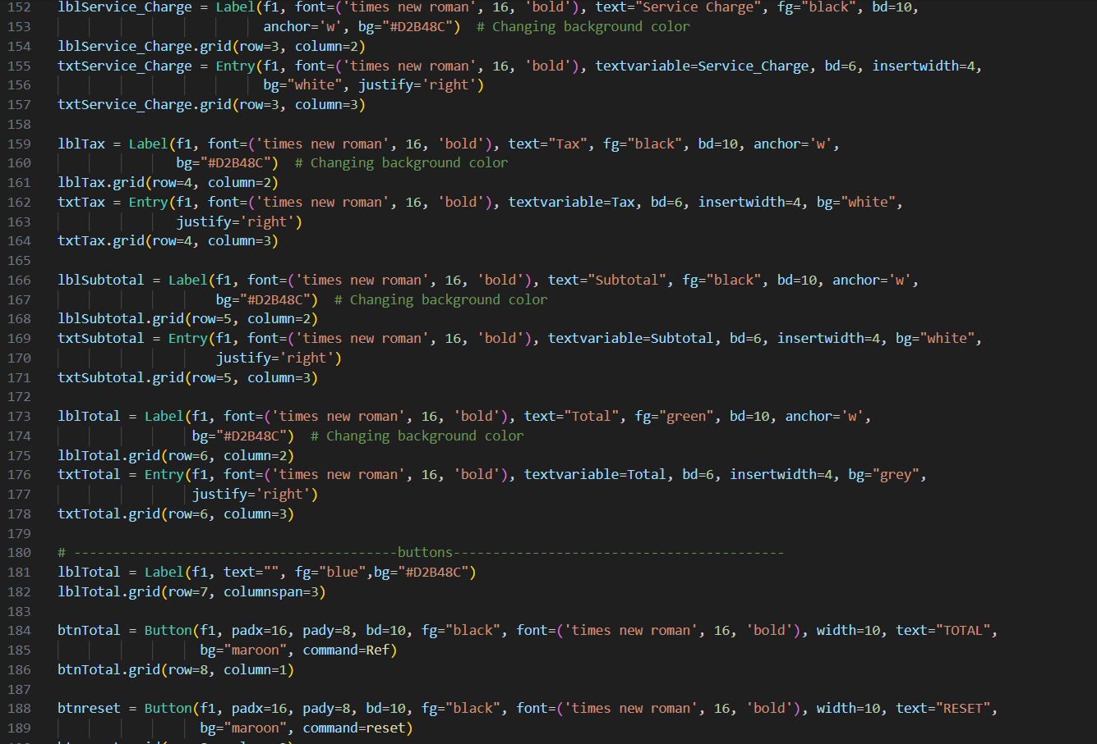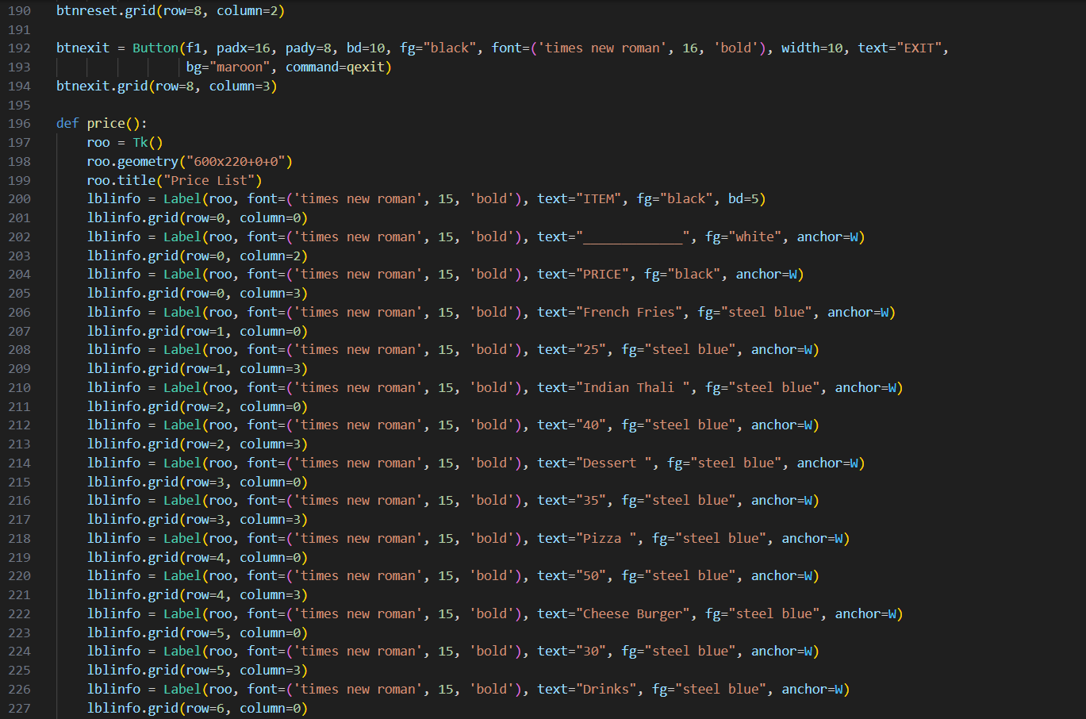

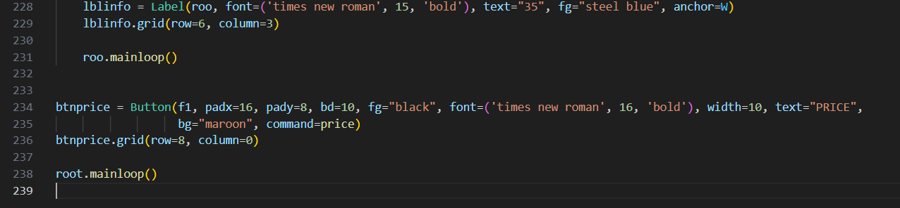

**OUTPUT:**

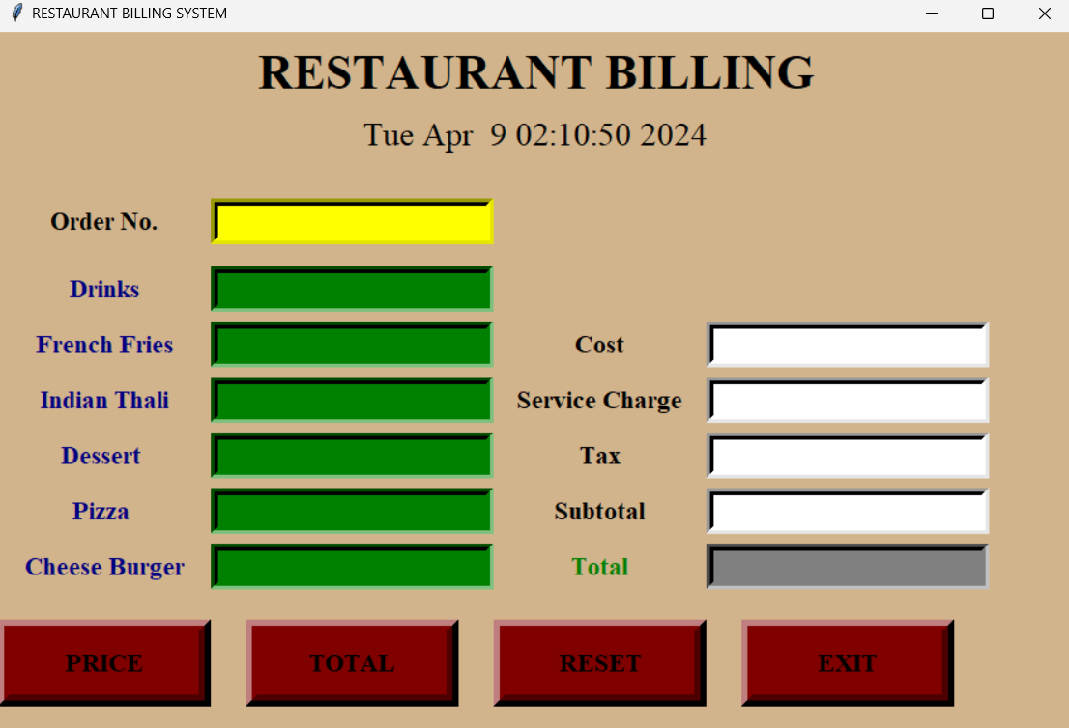

**SAMPLE OUTPUT:**

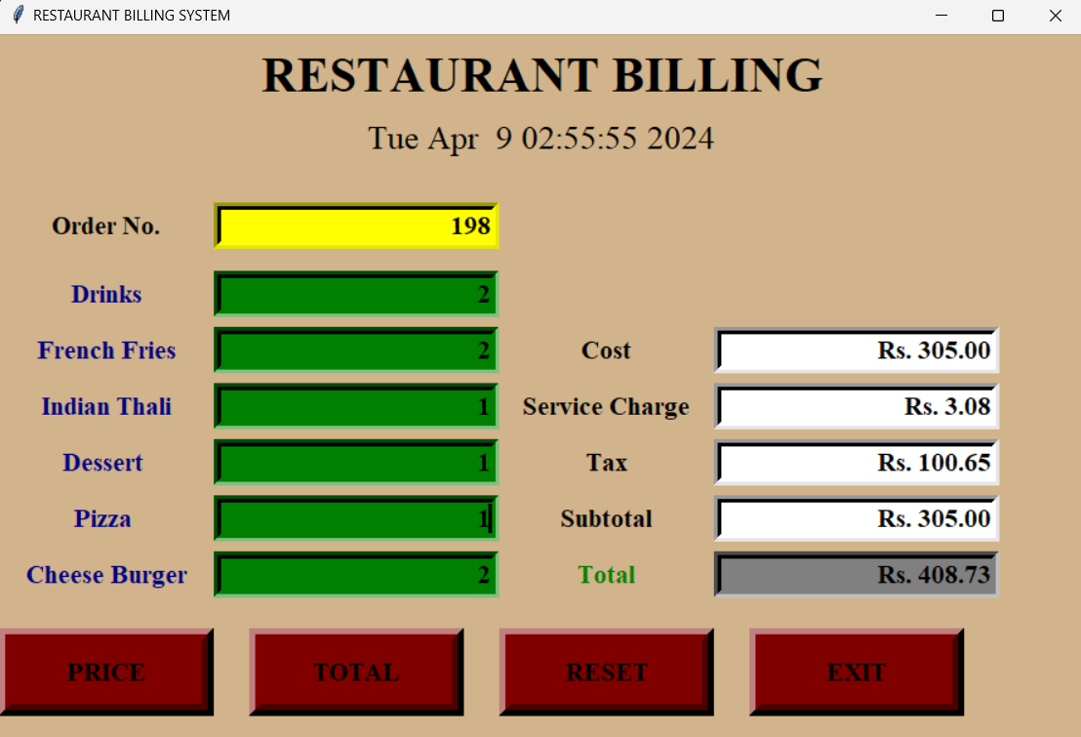

**CHAPTER 5 SYSTEM TESTING**

# 5.1 INTEGRATION TESTING:

In this type of testing, we test various integration of the project module by providing the input. The primary objective is to test the module interfaces in order to ensure that no errors are occurring when one module invokes the other module.

**CHAPTER 6**

**CONCLUSION AND FUTURE WORK:**

## Conclusion:

To conclude, this project helps to maintain the record for any particular restaurant or restaurant. It is an advance and user-friendly interface, which will manage all orders and menu of the restaurant. It helps to take orders and display order and show bill. This also allows adding item, deleting item, editing item and displaying menu. It helps in ordering food, which leads to bill generation. It will help several restaurants to take orders of customers easily and it helps user to generate bill according to the quantity of food items. This project is aim at developing an efficient food ordering system, which can be use in small places. It is also use to simplify their operational and managerial tasks. It also helps to store the records of all the bills generated for further analysis. Overall, it will help both user and customers and it will simplify the phase of ordering food.

## Future Work:

* We will be adding the features of printing the date also with bill, so while displaying the total sale report we can sort it date wise.
* Moreover, we will add edit the bill option too, if the bill has been generated for a particular order and customer wants to add more items in that bill, so we can edit the order and regenerate the bill.
* Create a login, so that the system is more secured.
* And allow the customers to process their orders as a guest



**FUNCTIONS PERFORMED BY GROUP MEMBERS:**

## MD. JUNED EQBAL & MD. ALTAMASH DANYAL: Billing (Sale report, generation of bill, preview of specific bill).

PRAKASH KUMAR: **Display Menu, Add, Edit function.**

MD.DILSHAD ALAM: **Main menu, Take order function.**

SHUBHAM KUMAR: **Delete, Edit function**

**CHAPTER 7 REFERENCES**

https://[www.programiz.com/cpp-programming](http://www.programiz.com/cpp-programming)

<http://www.cplusplus.com/doc/tutorial/>

https://[www.youtube.com/watch?v=UzDDHTQ12dM](http://www.youtube.com/watch?v=UzDDHTQ12dM)

https://codescracker.com/cpp/cpp-binary-files-basic-operations.htm

https://halls-of-valhalla.org/beta/codes/program-to-create-add-modify-delete-display-search-in-binary- file,72/

**Full Signature of Supervisor: Full signature of the student:**



##### PLAGIARISM SCAN REPORT

| 6%  Plagiarized | 94%  Unique | **Date** | 01-04-2024 |
| --- | --- | --- | --- |
| **Words** | 984 |
| **Characters** | 6787 |

**Content Checked For Plagiarism**

A PROJECT REPORT on “ RESTAURANT BILLING SYSTEM ” Submitted to KIIT Deemed to be University In Partial Fulfillment to the Requirement for the Award of BACHELOR’S DEGREE IN INFORMATION TECHNOLOGY UNDER THE GUIDANCE OF SCHOOL OF COMPUTER ENGINEERING SCHOOL OF COMPUTER ENGINEERING KALINGA INSTITUTE OF INDUSTRIAL TECHNOLOGY - 751024 Apr 2024 KIIT Deemed to be University

School of Computer Engineering Bhubaneswar, ODISHA751024 instrument This is certify that the project entitled RESTAURANT BILLING SYSTEM submitted by MD. ALTAMASH DANYAL(2106036),MD. DILSHAD ALAM(2106037),SHUBHAM KUMAR(2106070),MD. JUNED EQBAL(2106124),PRAKASH KUMAR(2106132) is cord of bonafide work carried out by them, in the partial fulfillment to the requirement fortheaward of Degree of Bachelor of Engineering( Computer Science Engineering OR Information Technology) at KIIT Deemed to be university,Bhubaneswar.This workisdoneduringyear2023- 2024, under our guidance. DATE 09/04/2024 PROJECT GUIDE Acknowledgement We are profoundly grateful to DR. ARUP ABHINNA ACHARYA of Affiliation for his expert guidance and continuous encouragement throughout to see that this project rights its targets in its commencement to its completion. MD. ALTAMASH DANYAL(2106036),MD. DILSHAD ALAM(2106037),SHUBHAM KUMAR(2106070),MD. JUNED EQBAL(2106124),PRAKASH KUMAR(2106132)

TABLE OF CONTENTS

1. preface design points AND objects BACKGROUND OF design OPERATION terrain 2. SYSTEM ANALYSIS SOFTWARE demand SPECIFICATION GENERAL DESCRIPTION PROBLEM STATEMENT SYSTEM

ideal SOFTWARE AND tackle demand SOFTWARE demand tackle demand EXISTING VS PROPOSED SOFTWARE TOOL USED

3. SYSTEM DESIGN DATA FLOW DIAGRAM ’S 4. SYSTEM perpetration MODULE DESCRIPTION SCREEN SHOTS 5. SYSTEM

TESTING UNIT TESTING INTEGRATION TESTING 6. CONCLUSION & FUTURE compass 7. REFERENCES ABSTRACT The design

named “ restaurant operation SYSTEM ” is design with Visual Studio. restaurant proprietor has to maintain records of diurnal billing, which will be used to manage trade report. There will be numerous particulars available in the restaurant, numerous guests will be coming at different time for having food, they will be opting particulars from the displayed menu and their bills will be generated. This system will save time and will be easy to use when compared to homemade work that was done in paper.

CHAPTER 1 preface restaurant Management System is an operation, which will help caffs restaurants to optimize and control over their caffs

and restaurants menu. This operation helps the restaurants to do all functionalities more directly and efficiently. restaurant operation system

reduces homemade work and improves effectiveness and rate of work. It's specifically designed for restaurant billing operation and order taking operation system. This software helps to take food orders and display them. Also, help to maintain records in system and display total trade report. It's keeping a proper record of the bills. points AND objects The design end and objects that we will achieve after the completion of this design are; 1) To take orders 2) To add item 3) To remove item 4) To edit item 5) To display menu 6) To show bill 7) To display total trade reports Take Orders customer will take orders from the client, and only order will be taken at a time. After taking the order system will ask the client whether to add further item in the order if yes, particulars will be added and bill will be displayed. Add Item still, they can add through this function, If restaurant staff wants to the add any item in the menu list. It ’ll first ask to enter item law and also to enter the price of the item. also the new item will be added to the menu. Edit particulars still, they can edit it If the operation of the restaurant wishes to edit the formerly added particulars in the menu. through this function. It could be the law of the item or the

price. cancel particulars If the restaurant has to remove some of it particulars from the menu list that they're no longer offering they can cancel that item from this menu by entering the item law. Display Menu When the guests come to give the order, menu will be displayed to them with their prices. Show Bill still, they can search that bill by entering If the operation of the



Page 1 of 2

restaurant wants to search a specific bill. the bill number. Total trade Report If the proprietor of the restaurant wishes to see his total trade report he can check the report through this function, which will display all the bills with their figures. BACKGROUND OF design restaurant Management System is grounded on a conception of ordering food particulars and generating total food cost. The customer can make an order by opting from the main menu. This mini design contains limited features, but the essential bone

. Talking about the features of the food ordering system, the system displays a menu of all food particulars with their

prices and the customer has to elect any of them to order. There should be one order at a time. After opting , an order the system asks whether to add further particulars, and also proceeds to the volume of that item.

After all these, the system saves the order and asks whether to add another order or not. also the system generates the bill for the client. At last, a bill damage is displayed with the bill number, and the total bill quantum in rupees. CHAPTER 2 SYSTEM ANALYSIS In this chapter, we will bandy and dissect about the developing process of restaurant Management System

including software demand specification( SRS) and comparison between being and proposed system. The functional and non-functional conditions are included in SRS part to give complete description and overview of system demand

before the developing process is carried out. Besides that, being vs proposed provides a view of how the proposed system will be more effective than the being one. SOFTWARE demand SPECIFICATION GENERAL DESCRIPTION restaurant Management System is a motorized system, which helps customer( eatery) to manage the client bill records in electronic format. It reduces the threat of losing records, and reduces time consumption. It can help customer to manage the orders and bills of guests efficiently. PROBLEM STATEMENT The problem passed before having motorized system includes • Homemade ordering was time consuming. • Bills were less accurate. • Ordering food was complicated for guests. • Managing records in the form of papers was a delicate and parlous task. SYSTEM ideal • enhancement in control and performance. • The system is develop to manage up with the current issues and problems of taking food orders & billing. • It has reduced time consumption. • Bills are more accurate. • Bill generation is easier than ahead. • It's easier to order food for a client. • Records are more secure in motorized form rather than paperwork.

##### Matched Source

**Similarity** 10%

**Title**:github.com › shainahegde51 › restaurant_Management_Systemrestaurant_Management_System_Project - GitHub

restaurant Management system is specifically designed for café billing management and order taking management system. This software helps to take food orders and display them. Also, help to maintain records in system and display total sale report. It is keeping a proper record of the bills.

https://github.com/shainahegde51/restaurant_Management_System_Project/



###### Similarity 5%

**Title**:Solved just give the answer in different section depending

There should be one order at a time. After selecting an order, the system asks whether to update the order or not, then proceeds to the

[https://www.chegg.com/homework-help/questions-and-answers/give-answer-different-section-depending-upon-classes-](http://www.chegg.com/homework-help/questions-and-answers/give-answer-different-section-depending-upon-classes-) need-quick-answer-code-implemented-ja-q78733503



###### Similarity 5%

**Title**:[www.chegg.com](http://www.chegg.com/) › homework-help › questions-andSolved Food on Wheels Food on Wheels is a Food Delivery ...

After all these the system saves the order and asks whether to add another order or not. Then the system generates the bill for the customer. At last, a bill receipt is displayed with the bill number, order number, and the total bill amount in rupees. [https://www.chegg.com/homework-help/questions-and-answers/food-wheels-food-wheels-food-delivery-management-](http://www.chegg.com/homework-help/questions-and-answers/food-wheels-food-wheels-food-delivery-management-)

system-available-desktop-application-appl-q79307379/





Page 2 of 2